English paper template for International Conference on Literary Tourism
cm 3

(Topic of the paper up to 12 words)

----- One line space -----
Full name of first author,* , second author, … (without any prefix like Dr., Mr., …)
First author affiliation, Email
Second author affiliation, Email
…

Abstract
3.5 cm
3.5 cm
For your paper to be published in the conference proceedings, you must use this document as both an instruction set and as a template into which you can type your own text. If your paper does not conform to the required format, you will be asked to fix it. The abstract portion is a narrative presentation without references. The abstract should give a concise and informative description of the paper, between 80 to 300 words. Its left and right margin must be equal to 3.5 cm.

Keywords: Three to five keywords or phrases, separated by commas.

1. Introduction
This instruction give you guidelines for preparing papers for 1st International,5th national Conference On Management Of Technology. An easy way to comply with the conference paper formatting requirements is to use this document as a template and simply type your text into it. All papers must be written by Microsoft Word 2003 or 2007 and be submitted respectedly in *.doc format or *.docx one.
2.5 cm
2.5 cm
Your paper must be in one column format with a single line spacing between lines and the margins must be set as follows:
- Top = 3 cm
- Bottom = 3 cm
- Left = Right = 2.5 cm

2. Paper lenght
The length of your paper should not exceed 15 pages. Prepare your printer-ready paper in A4 size, which is 210mm (8.27") wide and 297mm (11.69") long. Please do not change the paper size and the pre-defined styles.

3. Equations
Equation must be written in a two column table with no border like the following example. (Using Microsoft Equation recommends)
(1)
(2)

4. Tables and Figures
cm 3
All of the Tables and Figures must be in the center of the page. Tables and figures should be cited consecutively in the text. Title of the Tables must be in the top center of the Table and the title of Figures must be in below of them at center. Before and after the Tables and Figures, an empty line must exist (Times New Roman 11pt. Normal). Table 1 is an example for the authors, that shows the necessary information to write papers.

Table 1. Necessary information to write papers
Subject | Font | Size | Type
Paper topic | Times New Roman | 17 | Bold
Name and Family of Authors | Times New Roman | 11 | Bold
Short Address of Authors | Times New Roman | 9 | Italic
Email of Authors | Times New Roman | 10 | Italic
Sections title | Times New Roman | 13 | Bold
Sections subtitles | Times New Roman | 11 | Bold
Abstract text | Times New Roman | 10 | Normal
Keywords | Times New Roman | 10 | Normal
Main text | Times New Roman | 11 | Normal
Footnotes | Times New Roman | 9 | Normal
Title of Tables and Figures | Times New Roman | 9 | Bold
Text of Tables | Times New Roman | 8 | Normal
References | Times New Roman | 10 | Normal
Page number | Times New Roman | 10 | Normal

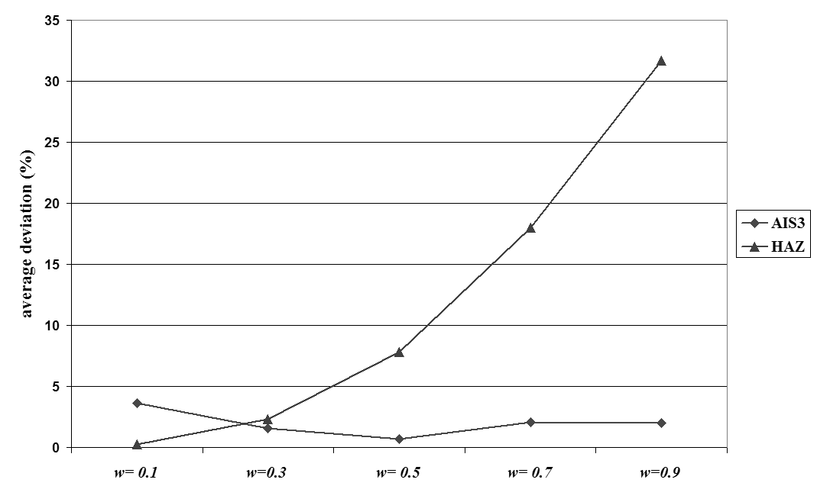
Figure 1. Example figure

5. Conclusion
Conclusion may review the main points of the paper, do not replicate the abstract as the conclusion. It might elaborate on the importance of the work or suggest applications and extensions.

Acknowledgments
Acknowledgments section is optional for paper. The heading of the Acknowledgment section and the References section must not be numbered.

References
All reference items must be in 10 pt font. Please use Regular and Italic styles to distinguish different fields as shown in the References section. Number the reference items consecutively in square brackets (e.g. [1]).
When referring to a reference item, please simply use the reference number, as in [2]. Do not use “Ref. [3]” or “Reference [3]” except at the beginning of a sentence, e.g. “Reference [3] shows …”. Multiple references are each numbered with separate brackets (e.g. [2], [3], [4]–[6]).
Examples of reference items of different categories shown in the References section include:
- example of a book in [1]
- example of a conference paper in [2]
- example of a journal article in [3]
- example of a website in [4]
- example of a PhD dissertation in [5]

[1] Meredith, J.R., and Mantel, S.J., "Project Management: A Managerial Approach", John Wiley & Sons,1998.
[2] Nosoohi, I., and Shahandeh, A., "Contract design for increasing supplier’s capacity in a two stage supply chain, with stochastic demand", Proceeding Of IEEE International Conference on Logistics Informatics and Supply Chain Management, pp. 2514-2518, 2009.
[3] Kianfar, K., Fatemi Ghomi, S.M.T., and Karimi, B., "New dispatching rules to minimize rejection and tardiness costs in a dynamic flexible flow shop", International Journal of Advanced Manufacturing Technology, Vol. 45, No. 8, pp. 759-771, 2009.
[4] www.iiec2010.com.
[5] Ahmadi, M.A., "On Extensions of Fishers Linear Discriminant Function" , PhD Dissertation, MIT, Cambridge, MA, 1982.

,* Corresponding author: Position and Special field of the first author
Position and Special field of the second author

